

**All Citizens Christian Church Calgary**

**Bible Study:** Tuesday, April 9th, 2024. **Topic: THE NEHEMIAH CHRISTIAN**

**Text: Nehemiah 1 and 2**

When I began to prepare for this Bible study, I read a statement in one of the books I was using. It said there are three types of people:

1. Those who do not know what is happening.
2. Those who watch what is happening - Hanani.
3. Those who make things happen - Nehemiah.

The aim of this Bible study is to put us into the third category. The reason for this is that God did not design anyone to be in the first two groups. God designed us with an assigned purpose on earth. We are all on earth to please God and fulfil His will. We cannot achieve this by been ignorant or by been nonchalant (indifferent). We can only fulfil God’s reason for making us when we make things happen.

**Gen 1:28** *Then God blessed them, and God said to them, “Be fruitful and multiply; fill the earth and subdue it; have dominion over the fish of the sea, over the birds of the air, and over every living thing that moves on the earth.*

”I see purpose like eleven players on a soccer field itching to achieve one objective on the pitch, we may have the strikers, the attackers, the wingers, the defenders, goalkeeper etc. These people have one purpose, and it is to get the ball into their opponent’s goal and to ensure that their opponent does not get the ball into their goal. Every player must fulfil his role to achieve the purpose of the game. The Apostle Paul compared this to the human body in **I Cor 12 12-30**. We are all players on earth or in the church.

The reason for this Bible Study therefore is to help us re-align our thoughts so we can start to think of our purpose on earth with a view to achieving what the Lord has set for us. Do not tell me that your purpose on earth is to become an engineer or whatever career you find yourself in so that you can earn money. Engineering may be a means to an end but not the ultimate purpose for your being on earth.

**Who was Nehemiah? Neh. 1:1, 2:1, 9.**

There were three principal characters who contributed in rebuilding Jerusalem. They were Zerubbabel - 538-515 who built the temple, Ezra - 458-456 who restored the people to the law of Moses by bringing a copy of the Mosaic law and Nehemiah - 444-432 who rebuilt the walls of Jerusalem. Nehemiah appears to have been a grandson of one of one of the people taken captive from Jerusalem by Nebuchadnezzar. He was most probably born in exile but he had a passion for his people Israel. He was an important staff to King Artaxerxes as he served as a cupbearer to the king.

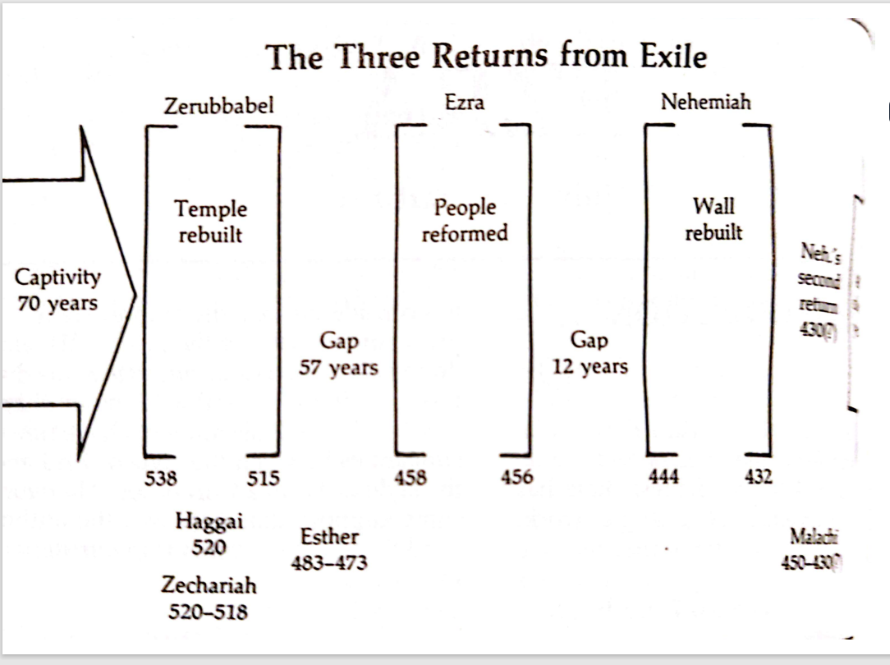

*The Bible Knowledge Commentary*

**Nehemiah’s approach -The leader and the challenge of leadership**

What are some of the challenges of leadership you know using the Nehemiah example?

* Making others understand your challenge. Hab 2:2
* Making people agree to your leadership.
* Getting people to join you to fix the problem.

**See yourself as a leader (everybody a leader?):** Think of my analogy about the 11 football players and you will discover that every member of the team is a leader at his/her wing. Others may assist him/her from time to time: You are the leader because you can see the challenge at your spot more than every other person and you can re-organize if need be because you understand the challenge more than the others. It is your job to paint the challenge before others. **Hab 2:2**. Whose duty is it to make a vision plain? (That explains why most people hate the position of leadership) The challenge of making a vision plain is huge. Some may not agree, and some just may not get it.

1. **Identify the challenge**: What was the challenge that Nehemiah identified and wanted to solve. **Neh. 1:3-4, 2:3-8**, **Dan 9:24**
   1. How did he identify the challenge? *By asking*. How did Daniel identify the challenge? **Dan 2: 2**. By reading. **Deut. 1:6**, **Amos 6:1-2 Message** The beginning of the achievement of your purpose is concern. Comfort steals purpose by putting you at ease. If you are in love with ease in life, you may never accomplish your purpose. Some of the people that God has used to accomplish purpose in life were people who although were comfortable where they were, sought to inconvenience themselves to achieve God’s set purpose for their lives. Examples are Esther, Daniel, and Nehemiah. If you become too comfortable in your place and forget your purpose in life, you may be exhibiting ingratitude to the one that gave you that comfort.
   2. What have you identified as the challenge of the church in Calgary and what have you identified as the challenge in ACCM.
   3. What is the difference between Nehemiah and Hanani? **1:2, Psalm 137, Esther 4:1-4, I Sam 17:23-27**
2. **Decide how to approach the challenge**: What was Nehemiah’s decision? Remote or onsite? Confer with people or refuse to talk to anyone about it. Daniels Approach (**Dan 2:17**), Nehemiah’s approach, (Neh. 1:4), Abraham’s Approach (Gen 22:2-3), Paul’s approach (Gal 1:15-17)
   1. Why do you think Nehemiah took that decision to be on site? Nehemiah could have begged the King to send someone to Jerusalem to do the work.
   2. How did David decide to solve his problem? Some problems may be unique, but some are similar. **I Sam17:40** – Start from what you know.
3. **Start your plan**: Planning is a process of deciding what to do about the project before you start the project.
   1. Pray- Know when to pray and when to work Ecc. 3:1. It is best to start every plan with prayers.
   2. Based on your evaluation of the situation, decide on the way forward
4. **Why is it important to fulfil our purpose in life?**
   1. A fulfilled purpose opens the door for our miracles. Our blessings are hidden in the fulfilment of our purpose. **I Kings 17:8-16, II Kings 4:8-17**.

Nehemiah had a purpose in life. Serving in the king’s court was not his purpose but a means to achieving a purpose. It is easy to assume that our daily means of livelihood is also our purpose in life. It may as well be. However, to confirm that, you may need to find out how much you are use that means to please God. If all you are doing with your daily job is just getting your salary which feeds you and your family, with God on the side burner, you may need to check very carefully if you are fulfilling your purpose on earth. Also, how many people have you used that calling to direct to God? For Nehemiah, serving in the king’s court was a means to achieving his purpose on earth.

1. **Why do some people not fulfil their purpose on earth?**
   1. Distractions – Fake pastors, insults in church, family challenges **Luke 10:38**,
   2. Nonchalance: **Neh. 1: 2-3, I Sam 17:26**
   3. Anxiety: **Matt 6:31-34**
   4. Ignorance **I John 4:1, Hosea 4:6**
   5. Misunderstanding of mission: **Numbers 13:17-20, 26-33**
   6. **Disobedience: Nothing brings a setback to anyone more than disobedience.**
2. **Analyze Nehemiah’s strategy**.

**Neh. 1:1-5**

I have decided to have a statement for our gist parlors regularly before we start the gist session. **FOR TODAY, OUR GP STATEMENT IS “IT IS THE INTEREST THAT GENERATES THE VISION”**.

As I was praying this morning, the Lord sent some idea into my head which spurred me to start to pray for our church in that direction. I was hearing in my spirit that what set Nehemiah apart was the ability to identify challenges and see them as opportunities. I found that it was a character trait of people who become successful in life. Others may stay in a place and see nothing or just become simply ‘unaltruistic’ about the situation. Because these people think only about themselves, their circle of thought is small and for that reason, they tend not to be very successful in life. Hanani had a brilliant opportunity to write his name in gold, but he ignored it because he felt there was nothing he could do and passed the story to Nehemiah who saw the challenge and the opportunity to make a difference. The people who think outside their immediate circle are the ones that think of NETFLIX – 279 billion. Amazon – 1.9 trillion, Uber – 134 billion. These are people who do positive things that others are either not seeing or they are seeing and ignoring. People who think like Nehemiah tend to become successful in their personal endeavors. This attitude could be hereditary, or it could be developed or learnt. As a church we can make a difference by seeing what other churches cannot see. Most people love to be copycats rather been ingenious. As I thought about this, my mind went to the individuals in church. I found that that people who exhibit Nehemiah’s character tend to be successful in their personal lives and businesses. (Some would rather gossip than make a difference – Gossip never improves any situation. At best it leaves the situation as it is or makes it worse by chasing some away) I know someone will tell me that is who he or she is. I will only accept this statement from anyone if that person is completely accomplished on earth and the Lord is completely pleased with him or her and that fellow thinks there is no other thing to do. In the Holy Ghost culture, we continue to move forward because going forward is easier and faster. So, what were Nehemiah’s strategies.

1. **Seek to know**: Nehemiah sought to find out the situation – he was concerned. Remember today’s GP statement. **Neh1:2, Dan 9:2. I Sam 20:26**. Seek to know for progress and not for destruction.
2. **Don’t just walk away**: What can be done about the situation: **Rom 2:13, Matt 7:24**. When you identify a need and you begin to find solution to that need you become a Nehemiah Christian who begins to attract that Lord’s blessings.
3. **Pray:** Why do we pray? The major difference between the believer and the non-believer is the spiritual aid we get through prayers. Prayer activates heavenly grace to make things possible and it also activates the supernatural and helps in the realm of worries. Human efforts alone may bring us victory but many times at terrible cost and maybe excessive efforts. Compare and contrast the prayers of Nehemiah and that of Daniel. **Dan 9:13-19, Neh. 1:6-11** (focus on verse 19 in Daniel and 11 in Nehemiah)
4. **Seize the opportunity to talk to his boss after 4 months**. **Neh. 1:1 2:1-** What did Nehemiah pray for, for four months? Was it because he had no faith?Nehemiah explains the reason for his sadness and the kings takes it from there. This perhaps talks about the relationship between Nehemiah and the king. Be careful relationships play a lot of role in success.
5. **Examine Nehemiah steps to respond to the king**
   1. He prayed
   2. He chose his words, if it pleases the king. Our words make or mar us. Whether to your friend, spouse or boss. Before you use the words I don’t care, think of the consequences. When you become rude to people when they have not offended you, heaven could stand for them. **Dan 2:14-16, Col 4:6**
   3. ‘I ask that you send me’. What is the difference between that and let me go to Judah. **II Kings 6:1-4**.
6. **Request for letter of passage through the regions beyond the river**. **2:7.** Take advantage of an open door. **Rev 3:8, I Cor 16:9** The beginning of stress in life is not to identify opportunities. You need prayer to show you these doors when they open. When doors open, Prayers, knowledge, relationship etc. will help you to see the open doors and faith will help you to persist. That a door is open does
7. **Request for resources to help with the building**. **2:8.** Explain Verse 8b And the king granted them according to the good hands of my God upon me. (Grace and favor). Make use of the resources available to you for kingdom work. Finance, knowledge, access, .(He made plans for himself – I believe that Nehemiah was still be paid by while he undertook this job in Jerusalem)
8. **Why will the king provide guard even when he did not request for it?** The king provided his army with him**. 2:9**, (Favor) **Obedience and service to God and to authorities brings favor** - **Prov 3:1-4, Esther 2:17**. Compare and contrast rights vs favor or grace. You could earn both but you may not be given favor or grace and you cannot complain or go to court of you are not granted favor or rights. There is a statement like your right but no word like your favor. What is interesting about favor and grace is that you cannot determine if you have earned it. It is the giver that determines if you have earned them or if he would release them to you. Example of Grace could be found in **Matthew 20:1-16.** I spoke about the priming of favor in one of my messages. Favor can make you skip the queue. IMPORTANCE OF FAVOR IN THE LIFE OF A PERSON: Ecc 9:11, II Cor 9:8, Gen 39:3-5, Daniel 1:9 (My experience with Taffy Jones)
9. **Opposition (physical or spiritual) even in the face of obedience**: Compare and contrast the opposition experienced by Daniel and the one experienced by Nehemiah. **Dan 10:12-14, Neh. 2:10, 19**.

These were both spiritual oppositions, but the difference was that one was directly by the spirit and the other manifested through men. How do you challenge both. Because one is by men you pray and confront the men while the other is prayer, prayer and prayer alone.

Notice the progressive nature of the opposition of Sanballat and Tobiah: **2:10, 19-20**. Opposition may not just come and disappear. You will have to constantly resist the devil.

Why will someone be opposed even when he is in God’s will? Some people believe that if you are in the will of God there will be no challenges whatsoever. There are people who will be angry at you for no reason and there will be unfavorable circumstances at times like it happened to Apostle Paul in Acts 28. **Luke 21:16-19, I Cor 16:9**, **Acts 28: 1-6**

How do you overcome opposition? **Eph 6:10-18.**

* In some cases, there is nothing you can do, you may just have to leave the situation to God.
* In other situations, you may simply ignore the people and continue with what you are doing.
* In some situations, you may just have to pray for help from God.
* In other situations, you may have to ask the Lord for wisdom to answer your detractors.

How did Nehemiah respond to his critics to enable him focus on his purpose? **2:19-20. I Sam 28:28-29.**

What was the substance of his response? Faith and work

1. **He was in Jerusalem quietly for three days before embarking on the reason for his mission.** Why would he have done that and what lessons do we learn from that? **Mark 6:31, Deut. 5:12-14**
2. **He went to inspect the work.** **2:11-16.** What is the importance of doing a proper assessment of the work before starting**.** There is part of military that is so important for the success of any war, and it is called recce, a short word for reconnaissance (intelligence gathering). Recce is not planning. You use the recce result for planning **Joshua 2:1, Num 13:1-2**
3. Making the vision plain to the people **2:17** – these people saw the wall challenge so why did they not do something about it?
4. What was the importance of telling them about his favor with the king? **2:18**. To perhaps eliminate the fear that some may have that he is working against the king.

What are some of the challenges you have identified in this church and in the Calgary church?

What are your strategies to fix them?

Chapter 3. Strategies for Building – Break the whole project down into bits

Chapter 4 Strategies of the Enemy, Energizing the team, know the times and seasons, There is a time to fight and there is a time to build and there is a time to pray

Chapter 5 Caring for the builders – Sign of true leadership

Strategies for building